Apple apple tv 4k 800 S4

**Introduction:**

Apple company is one of the largest companies in the world and is one of the most important tech giants of the modern era. They are the frontrunners along with amazon in the competition of most unique technologies and a mammoth market value. Through the years, we have seen Apple bringing out several revolutionary products and ideas like iPhone, iWatch, etc. They introduced the MacBook in the laptops category and brought up their desktops and CPUs. Now the latest product to join this elite list is the Apple Tv 4k, the successor to the Apple Tv launched in 2007. The new Apple Tv 4k was launched in 2021 April and has got the tech-minded people talking.

**The new Apple tv 4k:**

**We have a lot of smart TVs and firesticks to update the TVs which aren’t smart enough. So, how does this Apple tv 4k stand out from its competitors? Well, this Apple Tv 4k comes with a sleek design and quite a lot of new features which would be a product people will love to have in their houses. The Apple Tv 4k comes in 2 variants: The 32 GB space-variant and the 64GB space-variant. According to Reliance digital, approximately the 32GB model is priced at Rs.17500 and the 64GB model is priced at Rs.19500. It is easy to use and is a good device for Apple lovers and Tech-lovers. It has been gaining a lot of buzz among Apple users but not everyone may agree with this statement.**

**Unimpressed generalists:**

Although the supporters of Apple, Mac OS lovers, and Apple users hail Apple Tv 4k as one of the best, generalists and neutral users think that this revolutionary device is a fancy one and call it a bit costly. They seem unimpressed with the new features and changes and just claim it as an ordinary adjustment and tinkering of the past version. People assert that products from other companies, such as Amazon Firesticks, are less expensive than Apple TV 4K. But its consumers disagree with this assertion since they prefer the high quality provided by Apple and believe the pricing is justified. Anyways, let's take a look at its specifications and come to a conclusion by ourselves.

According to Bob Borchers, the vice president of worldwide product marketing at Apple, "Apple TV 4K is in a class of its own, using a deep blending of Apple hardware, software, and services that provides a huge development to any TV for a very good cinematic experience. Customers can enjoy their favorite shows, movies, and other content in the finest quality with Apple TV 4K's easy and intuitive controls thanks to the A12 Bionic and the new revamped Siri remote. Of course, Apple TV 4K also gives quick access to Apple services and hundreds of other entertainment-related apps from the App Store.

**New features and advantages:**

There have been a lot of new features and improvements present in this Apple tv 4k. Some of the specific ones are Improved video performance, the new modified Siri remote, and it runs on the new tvOS. Let’s see more briefly each of these features:

1) tvOS:

The Apple Tv 4k operates on a new efficient operating system called ‘tvOS’. The tvOS is the most powerful television operating system to date and is very highly efficient. The people who created this masterpiece believe that Apple tv 4k can turn the television experience at home into a cinematic experience. Along with these, services of Apple such as Apple music, etc. can also be used on the TV.

2) Revamped remote:

The Apple Tv 4k’s remote or the ‘Siri remote’ as called by the experts, is now redesigned and revamped being fresher and smarter than ever. This device has quite a few changes and new functions. The new Siri Remote's revolutionary click pad control permits five directions for more accurate navigation and is touch-enabled for Apple TV customers' preferred fast directional swipes. The click pad is the perfect device for finding a certain moment in a film or television program thanks to a simple circular movement that converts the click pad’s outer ring into a jog control. The redesigned remote also fits the user's palm more comfortably thanks to its single-piece aluminum construction.

The new Siri Remote is the only remote needed to watch TV because it also has a power button for controlling a TV's power and a mute button.

**Conclusion:**

To contribute to the recent trend of smart Tv sticks, Apple has brought its revamped version of the Apple Tv 4k with quite a few good features along with a lot of advancements and specifications. But along with these improvements, the price of the product seems a little high. And a, it doesn’t have completely new or out-of-the-box features which makes people go crazy. So, when compared to the other similar products in the market, Apple may seem a bit more futuristic but not completely impressive, but surely a tough competitor in terms of features and specifications. If the price had been lower, Apple would have produced an exquisite Smart Tv device on the market.

**FAQ:**

**1) Which variant is better 32GB or 64GB?**

Both the 32GB and the 64GB variants are the same devices with the same specification but the 64GB has larger space. If you download a lot of applications and games, go for the 64GB variant. Otherwise, the 32GB variant is just fine.

**2) Is Apple TV 4k better than Amazon firestick?**

There have been a lot of comparisons going on on the internet on this topic, for now, let’s just say both are good in their way and you can choose according to your preferences.

**3) When will the next version of Apple tv 4k be released?**

According to rumors from an Apple analyst, Apple is planning to introduce a new version of the Apple tv 4k in the latter half of 2022.

Grammarly screenshot:

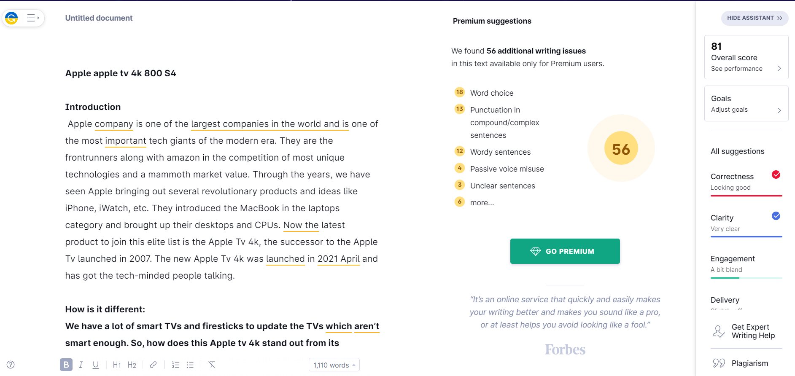

Quetext:

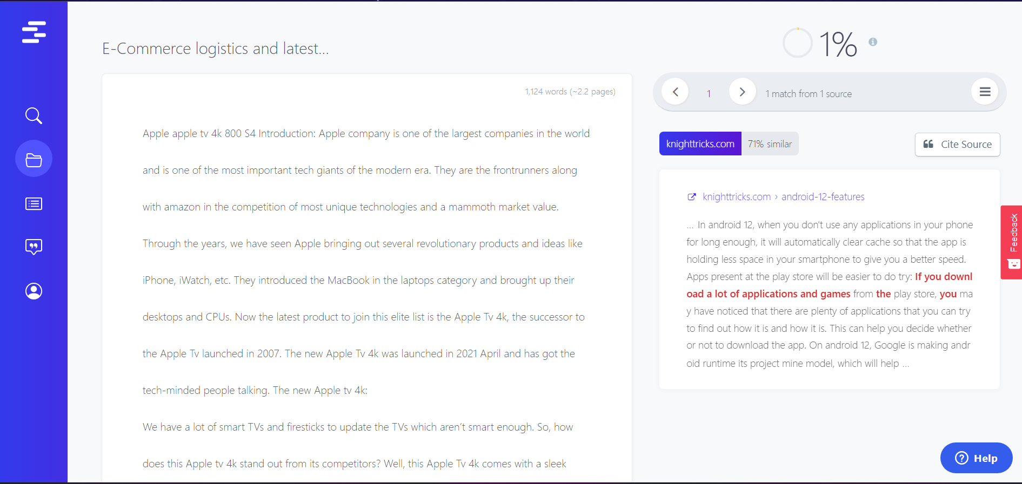

Spinmenot:

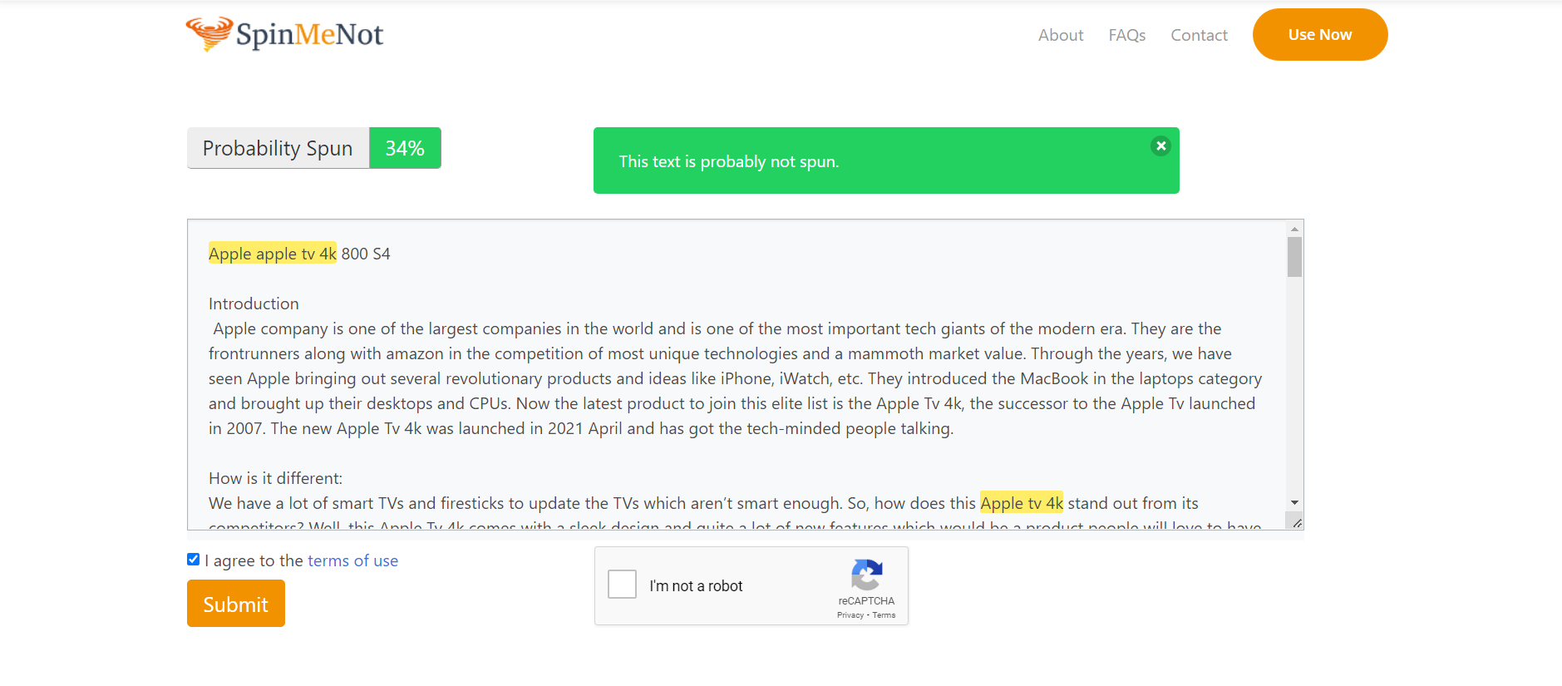

* An article by Sanjay M